

**Project Status Report**



**Project Name: SUSAN ICE STORE ORDERING AND INVENTORY SYSTEM**

**Department:**

**Focus Area:**

**Product/Process:**



**Prepared By:**

|  |  |
| --- | --- |
| **Document Owner(s)** | **Project/Organization Role** |
| Leonard Potian | Project Manager/Programmer |
| Nelaine Valdez | Document Manager/Programmer |
|  |  |

**Project Status Report Version Control**

|  |  |  |  |
| --- | --- | --- | --- |
| **Version** | **Date** | **Author** | **Change Description** |
| 1.0 | 06/21/17 | Leonard Potian | Submission of 2nd status report, activities per phase of (SDLC) and activity list |
| 1.0 | 6/21/17 | Nelaine Valdez | Submission of WBS, and Project Schedule |
|  |  |  |  |
|  |  |  |  |

**TABLE OF CONTENTS**

1 PROJECT STATUS REPORT PURPOSE 3

2 PROJECT STATUS REPORT TEMPLATE 3

2.1 Project Status Report Details 3

2.2 Project Status Report Template 3

3 PROJECT STATUS REPORT APPROVALS 3

4 APPENDICES 3

4.1 Document Guidelines 3

4.2 Project Status Report Sections Omitted 3

# PROJECT STATUS REPORT PURPOSE

The purpose of this report is the team will the submit their activity per phase of (SDLC), Activity list, WBS, and Project Schedule.

.



# PROJECT STATUS REPORT TEMPLATE

## Project Status Report Details

This is the second progress report that the group is required to submit the project documents like project schedule, activity list, WBS, and activity per phase of SDLC.

* [Status of the Project]
  + Our system is all about ordering and inventory system.
  + We submitted our project documents
  + We still improving our system

## Project Status Report Template

|  |  |  |
| --- | --- | --- |
| Project Name | | |
| Prepared By:  Leonard Potian | Date:  06/16/2017 | Reporting Period:  06/15/17 to 06/19/17 |
| Project Overall Status:  We submit the project schedule, activity list, WBS, and activities per phase of SDLC last June 21 2017 | | |
| Project Summary:  All documents in CSPOJ last term are in the git-hub and we will improve all the documents. | | |

# 

# PROJECT STATUS REPORT APPROVALS

Prepared by Leonard Potian

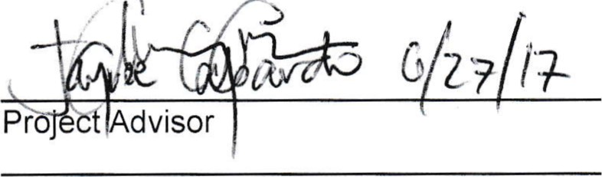

Project

Manager

Client

Sponsor

Approved

by

# APPENDICES

## Document Guidelines

## Project Status Report Sections Omitted

